**Smart Bank Locker based on Iris Recognition**

AZMAT HAYAT (SP17-BCS-006)

FAISAL AMEER (SP17-BCS-007)



**Supervised By**

Dr. Muhammad Sharif

**Department of Computer Science**

**COMSATS University Islamabad**

**Attock Campus**

**Smart Bank Locker based on Iris Recognition**

*Undertaken By:*

**AZMAT HAYAT**

CIIT/SP17-BCS-006/ATK

**FAISAL AMEER**

CIIT/SP17-BCS-007/ATK

*Supervised By:*

Dr. MUHAMMAD SHARIF

UNDERTAKEN

We certify that this is my/our own work. The work has not, in whole or in part, been presented elsewhere for assessment. Where material has been used from other sources it has been properly acknowledged. If this statement is untrue, we acknowledge that we will have committed an assessment offence and shall be liable to punishable action under the plagiarism rules of HEC.

______________ ____________________

Azmat Hayat Faisal Ameer

SP17-BCS-006 SP17-BCS-007

Dated: _________ Dated: _________

**CERTIFICATE OF APPROVAL**

It is to certify that the final year project of BS (CS) “Smart Bank Locker based on Iris Recognition” was developed by **Azmat Hayat (CIIT/SP17-BCS-006)** and **Faisal Ameer (CIIT/SP17-BCS-007)** under the supervision of **Dr. Muhammad Sharif** that in their opinion, it is fully adequate, in scope and quality for the degree of Bachelors of Science in Computer Sciences.

***Committee:***

1. External Examiner

(Examiner Name)

Designation

University Name

1. Supervisor

(Supervisor Name)

Designation

1. Head of Department

(HoD Name)

**PROJECT BRIEF**

|  |  |
| --- | --- |
| **PROJECT NAME** | SMART BANK LOCKER BASED ON IRIS RECOGNITION |
| **ORGANIZATION NAME** | COMSATS UNIVERSITY ISLAMABAD, ATTOCK CAMPUS |
| **UNDERTAKEN BY** | AZMAT HAYAT and FAISAL AMEER |
| **SUPERVISED BY** | Dr. MUHAMMAD SHARIF    ASSISTANT PROFESSOR  DEPARTMENT OF COMPUTER SCIENCE  COMSATS UNIVERSITY ISLAMABAD, ATTOCK CAMPUS |
| **STARTED ON** | 01-09-2019 |
| **COMPLETED ON** | 01-12-2020 |
| **COMPUTER USED** | HAIER, HP |
| **SOURCE LANGUAGE** | PYTHON |
| **OPERATING SYSTEM** | Windows |
| **TOOLS USED** | TKINTER, PYCHARM |

**Abstract**

In modern world machine learning involved in everything. Each person wants comforts in life with improvements in his/her productivity. Everyone wants perfection in duties. In past few years, a lot of work has been started in image processing and face recognition and detection systems have been developed. Some of the companies adopt these technologies to make their organization more progressive.

Our basic aim to build an Iris recognition security system for bank locker that is capable to secure bank lockers from illegal access. It will reduce the threat of misuse and traditional key locks approach.

**Table of Contents**

**1.** **Introduction 13**

**1.1.** **Brief 13**

**1.2.** **Relevance to course modules 13**

**1.3.** **Project Background 13**

**1.4.** **Literature Review 14**

**1.5.** **Analysis from Literature Review 14**

**1.6.** **Methodology & Software Lifecycle 15**

***1.6.1 Rationale behind selected methodology*** *15*

**2.** **Problem Definition 17**

**2.1.** **Problem Statement 17**

**2.2. Deliverable and Development Requirements 17**

*2.2.1* *Desktop Application 17*

*2.2.2.* *Database 17*

*2.2.3. Project Report 18*

**2.2.** **Current System 18**

*2.3.1* *Finger Print 18*

*2.3.2 Face Recognition 19*

**3.** **Requirement Analysis 21**

**3.1.** **Use Case Diagram 21**

**3.2.** **Detailed Use Case 22**

**3.3.** **Functional Requirements 23**

**3.4.** **Non-Functional Requirements 23**

*3.4.1.* *Security 24*

*3.4.2.* *Performance 24*

*3.4.3.* *Availability 24*

*3.4.4.* *Capacity 24*

*3.4.5.* *User friendly 24*

**4.** **Design and Architecture 26**

**4.1.** **System Architecture 26**

**4.2.** **Process Flow/ Representation 27**

**4.3.** **Data Representation 28**

**4.4.** **Design Models 30**

**5.** **Implementation 32**

**5.1. Project Implementation 32**

**5.2. Tools And Techniques 32**

*5.2.1*  *STAGES OF IRIS RECOGNITION 32*

**5.3. Main-Interface 33**

**5.4. Main Menu 34**

**5.5. Bank Employee Functionalities 34**

***5.5.1***  ***Register Manager*** *35*

***5.5.2 Access Locker Room*** *35*

**5.6. Bank Customer Functionalities 36**

***5.6.1 Locker User Registration*** *36*

***5.6.2 Locker Opening*** *37*

**6.** **Testing 40**

**6.1** **Project Testing 40**

**6.2** **Functional Testing 40**

***6.2.1*** ***Registration System:*** *40*

***6.2.2 Locker Room Access*** *41*

***6.2.3 Bank Locker User*** *41*

**6.3.** **System Testing 42**

**7. Conclusions 44**

**7.1. Conclusions 44**

**7.2.** **Future Work 44**

**7.3.** **References 44**

**Table of Figures**

Figure 2.3:1 Finger Print 19

Figure 2.3:2 Face Recognition 20

Figure 3.1:1 Complete System Use Case 22

Figure 3.1:2 Create Account 22

Figure 3.1:3 Locker Access 23

Figure 4.1:1 System Architecture 27

Figure 4.2:1 Activity Diagram 28

Figure 4.3:1 Level 0 Diagram 29

Figure 4.3:2 Level 1 Diagram 30

Figure 4.4:1 Sequence Diagram 31

Figure 5.4:1 Interface 35

Figure 5.5:1 Manager Registration 36

Figure 5.5:2 Locker Room Opening 37

Figure 5.6:1 Bank Locker User Registration 38

Figure 5.6:2 Locker Opening 39

Figure 5.6:3 Opened Locker 39

**List of Tables**

Table 1 Comparison with other existing systems 20

Table 2 Test case for Registration 41

Table 3 Test case for Manager Room Opening 42

Table 4 Test case for Locker User 43

**Chapter 1**

**Introduction**

# **Introduction**

Our project is based on iris recognition system to provide enhanced security to bank lockers. It will provide a secure and reliable security to important persons. It will overcome the problems of misuse and threats to personal assets and make a high end security system for personal valuable assets.

## **Brief**

An Iris recognition system will be capable computer application which identifies an eye and compares it with existing eye picture in the database.

An Iris recognition system use camera to capture bank employee and user eye retina image. It consist of database of employee and users that hold eyes images and its personal information. It perform pre-processing and detects images features and in post processing it make comparison with images stored in database.

In traditional approach locker security were made by keys and locks. Employee need keys to carry with them for entering the locker room. Users also need keys for their particular locker access It was difficult to keep keys with them every time. Also there is a chance that an unauthorized person can enter the locker room by using keys. Hence our proposed system overcome these problems and brings accuracy and security .

Methodology for this project will be according to Iterative Model. We will discuss about the selection of this model later.

Later on, in next chapters, we will discuss about the problem statement, solution & requirements, and diagrams related to our Project.

* 1. **Relevance to course modules**

This project is related to our courses, that we study during BCS. Project involves programming & logics, that we learn during our degree. For our project we are using python language. In the 6th semester, Artificial intelligence course is offered in which we learn python language. In 7th semester we are studying machine learning course. Our interface will be designed using Tkinter python GUI tools. The back end coding will be implemented using python.

* 1. **Project Background**

We are developing a Iris recognition security system for bank locker This system is base on desktop application. It will have a databases for bank manager and user who want to keep their valuable assets in bank lockers. Bank manager create his/her account. Using his/her login he can create account for the person for the locker using the personal credentials. When a person want to access the locker first a bank locker access is granted by bank manager using his iris verification. After that a person can access his/her locker using iris scanning process. If the iris scan is valid permission of access is granted otherwise some security alarm or message is generated.

It is mandatory for person to have his/her account to access the locker. On login screen iris is scan and using machine learning various pre processing are done. Camera capture the eye image and using python code we will pre-process that image and extract iris portion from that image. By means of ML algorithm feature extraction is done and base on some similarity algorithm comparison are made. On successful match the person can access his/her locker also its information is displayed on screen.

This system provide a high end and reliable security. It will protect the personal valuable assets from misuse. Every person can easily use the system and it is not easy to breach the security of system because it is using iris which is unique of every person. It will over come the problem of old fashion key and locks security which are difficult to maintain and also need security to keep them safe form illegal person.

* 1. **Literature Review**

Finger print security is common practice. In most of the organization it is also using for various authentication. Also there is work on iris recognition authentication but its practical implementation is not much. In this era there is huge focus on security people want the reliable and efficient system for securing their assets. There is huge contribution in machine learning and image processing and they are using in practical daily life example. People want these system in their life to get rid of out dated and less secure and less reliable system.

* 1. **Analysis from Literature Review**

The concept of the project is implemented in industry, most of the organization using the finger print system. In our university a finger base biometric attendance for teacher is also in use. The banks are using a finger print access to cashier room. But the iris base is not yet implemented at FYP level.

Instead of finger print we are using the iris recognition system. It will use iris of person eye for authentication process. Iris is more secure because it is in protective lid of eye and less chances of damage.

Behind the iris in future after completion of this main biometric verification we also implement the finger print in later stage if this module is implemented for enhancing the security by dual biometric verification also improve system usability.

* 1. **Methodology & Software Lifecycle**

Development of security system is not an easy task. Our system is based on machine learning and image processing. We need to test our models again and again for result improvement because ML algorithms require continuous change in variable to improve results and accuracy. Software Development Lifecycle we are using for our project is **Iterative Model.** We will start our work from image pre-processing. Image is processed before actual work. In that pre processing image is converted from colour to Gray scale to make it single channel. Than on that image other technique will be used to enhance image. After that the iris localisation will be carried out. It will detect the iris circular region that is region of our interest. Then the masking of that region applied o original image. So from that region we will extract features because these features will be used for verification purpose. We will perform normalization to that region. After that the normalization stage comes in that part we will convert the segmented iris result into the fixed dimension so that features extraction and matching becomes easier. This process gives spatially located features. Then a last stage come, in this stage we will do the features extraction and templates matching stages.

### **1.6.1 Rationale behind selected methodology**

The reason behind selection of this methodology and SDLC for our project is that the Iterative model works on repetition of processes. As we don’t know the result of Machine Learning algorithms which will work fine so we will work on set of software requirements and test the result, improve the result of our algorithm base on various conditions. We will identify the further requirements according to our need. At each iteration our software will improve the accuracy. We will repeat until our project is ready.

**Chapter 2**

**Problem Definition**

# **Problem Definition**

In this Chapter we are going to discuss about the problem statement in the current system and relate them to the solution provided by our project.

* 1. **Problem Statement**

Conventionally the Pin and Password are used for authentication process. The older method of security of bank locker was key and locks. They can easily be breach. It is also difficult to maintain the keys for each locker. The password protected techniques are secure but they can also be easily stolen or someone can observe and later can access their credentials. The other main flaw is that password and pin can be forgot. In the later stage a human body biometric recognition system introduce include face and finger print recognition. But the fact is that face of the person is changeable. In our purpose system we introduce an iris recognition for security system of bank lockers. An iris is protected by the eyelid it is also not change with time. Hence it is most secure and reliable security system for the bank locker. An iris unique patterns make it a most reliable and secure biometric system. These systems are more reliable for security purpose and authentication. An iris patterns do not change with time and also are unique of each individual.

## **2.2. Deliverable and Development Requirements**

Requirements gathering is important phase of software development. Before starting our project, we gathered our desired requirements in order to formulate and manage the designing phase.

**2.2.1 Desktop Application**

A desktop application is developed in order to provide the graphical user interface. It will consist of a login screens for both the bank manger and for person who want to access his/her locker. There is account creation screen for bank manger itself and bank manger setup or create account for person who want to use the bank locker.

**2.2.2. Database**

There should be database in order to maintain the record for both the bank manager and the person who want to use bank locker. The database should be consist of authentication credentials with some other personal information.

**2.2.3. Project Report**

A complete Project Report is also develop that includes Software Requirements Specification, Software Design Specification, Graphical User Interface Mock-ups, Test Cases, and other major tasks that we have performed.

* 1. **Current System**

Finger print, face recognition and some other biometric system are currently under use. Face recognition use the person face pattern for authentication persons. Another biometric system is finger print. Finger print sensor read the unique pattern from the person finger and these pattern are match with store patterns. On successful match the authentication process is carried out. All the biometric system work on same principle to extract features of different human organ and used in authentication purpose.

**2.3.1 Finger Print**

Finger print biometric system is the earlier concept and most widely accepted system. These system use finger patterns for validation purpose. Finger print patterns are unique even between two twins. But the finger are less protective as they are more usable and open. We are unable to purely depend on one biometric system so we will use it in future for cross verification purpose.

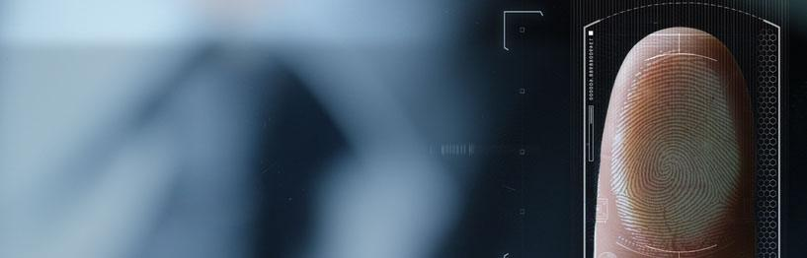

**Figure 2.3:1** Finger Print

**2.3.2 Face Recognition**

It is one of other biometric information processes. In face recognition system the face of person is captured. Then face localizer will detect the position of face and face alignment is performed. The pattern of face are match. But the face of person change with time so it has less usability

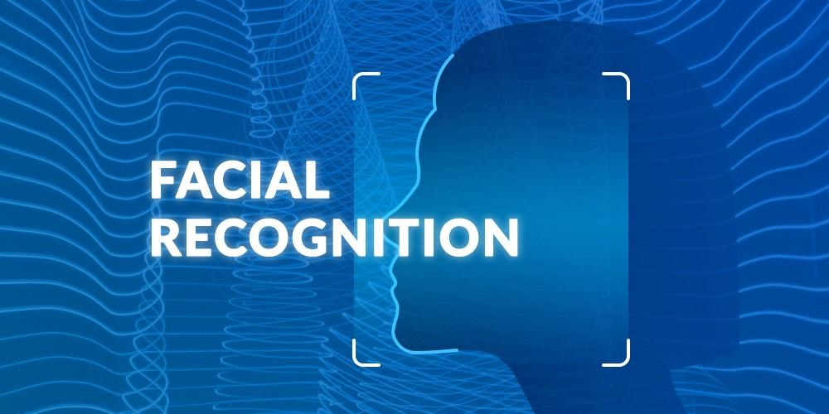

**Figure 2.3:2 Face Recognition**

|  |  |  |  |  |  |
| --- | --- | --- | --- | --- | --- |
| **Biometrics** | **Universality** | **Uniqueness** | **Collectability** | **Performance** | **Comparability** |
| **Finger Print** | Medium | High | Medium | Medium | Medium |
| **Face** | High | Medium | High | Low | Low |
| **Iris** | High | High | High | High | Medium |

**Table 1 Comparison with other existing systems**

**Chapter 3**

**Requirement Analysis**

# **Requirement Analysis**

* 1. **Use Case Diagram**

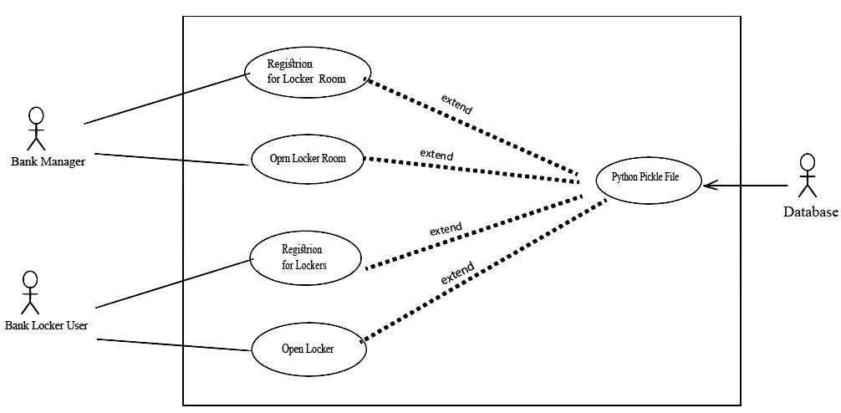

**Figure 3.1:1 Complete System Use Case**

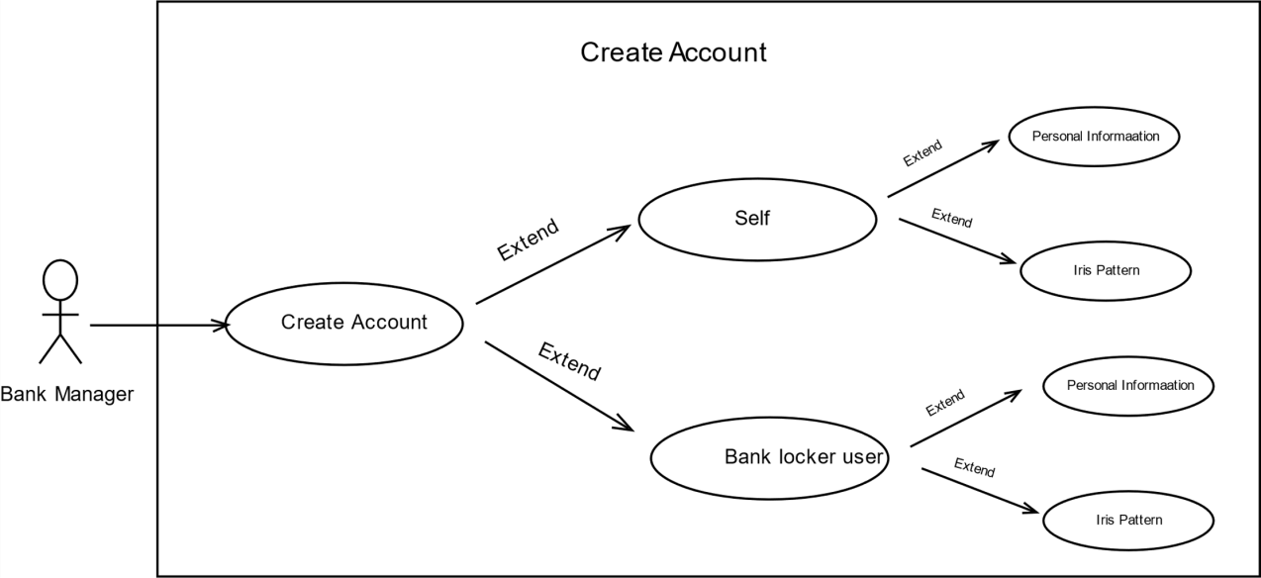

**Figure 3.1:2 Create Account**

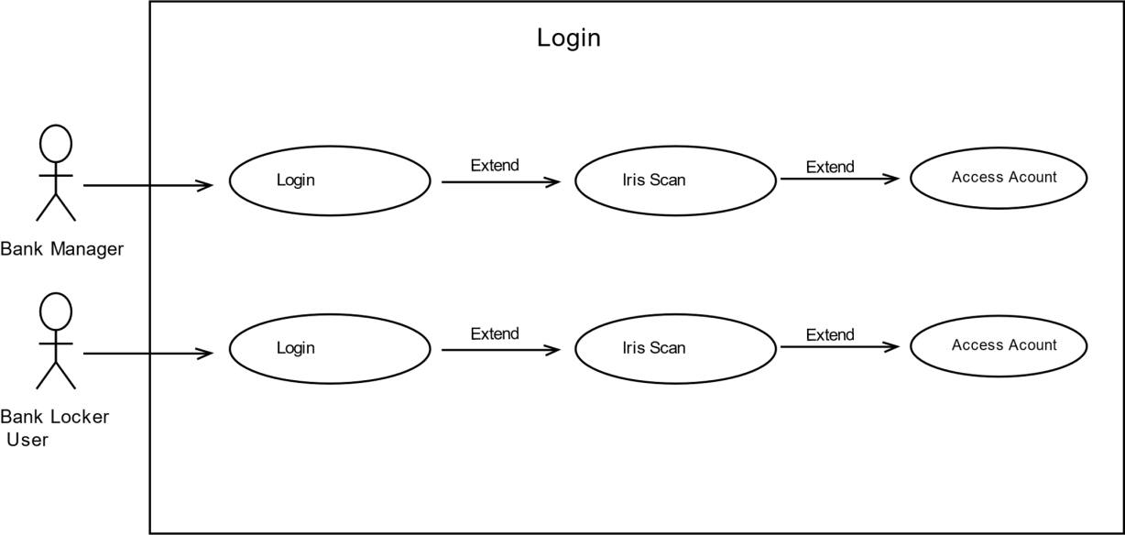

**Figure 3.1:3 Locker Access**

* 1. **Detailed Use Case**

**Table 3.2.1 Create Account**

|  |  |
| --- | --- |
| **Use Case Name** | **Create Account** |
| **Description** | GUI that allow bank manager to create account for self and for bank locker user in order to access system, |
| **Actor** | Bank Manager, bank Locker User |
| **Pre-Condition** | System must be have data base to store information |
| **Post-Condition** | on successful notification will be displayed and information store in database |

**Table 3.2.4 Login**

|  |  |
| --- | --- |
| **Use Case Name** | **Login** |
| **Description** | GUI for both bank manger and bank locker user in order to access system. Both can access system on iris scan successful validation. |
| **Actor** | Bank Manager, Bank Locker user |
| **Pre-Condition** | Must have account and information in database |
| **Post-Condition** | GUI must show successful login with information of person |

* 1. **Functional Requirements**

Functional requirement is defined as sets of input, behaviour and outputs. The functional requirement of any system is the specific behaviour and functions of that system.

**Table 3.3.1 FR-1**

|  |  |
| --- | --- |
| **Name** | * + 1. FR-1: Create Account |
| **Requirements** | User must have to create account to access the functionality of system |
| **Dependencies** | N/A |
| **Priorities** | High |

**Table 3.3.2 FR-2**

|  |  |
| --- | --- |
| **Name** | * + 1. FR-4: Login |
| **Requirements** | User login in order to access system. Login base on iris recognition and its validation |
| **Dependencies** | FR-1 |
| **Priorities** | High |

* 1. **Non-Functional Requirements**

Non-Functional requirement defines a function and its components.

* + 1. **Security**

The main focus of our system is security as system concern with valuable assets so the security must be high and trustworthy. Hence we are using iris recognition which are unique to provide high end security

* + 1. **Performance**

Performance of the system is important. We are trying to achieve performance for our system. We want a user real time experience. But as it is iris recognition system to provide high security so might some condition would effect the efficiency.

* + 1. **Availability**

Users can access the system anytime, anywhere without any interruption.

* + 1. **Capacity**

The system will be able to operate function for the maximum time of the day. The system does not need to process too much data, so it is easy to process.

* + 1. **User friendly**

Interface of our system will be easy to use so a person can easily use it and access the system without any deep knowledge.

**Chapter 4**

**Design and Architecture**

# **Design and Architecture**

* 1. **System Architecture**

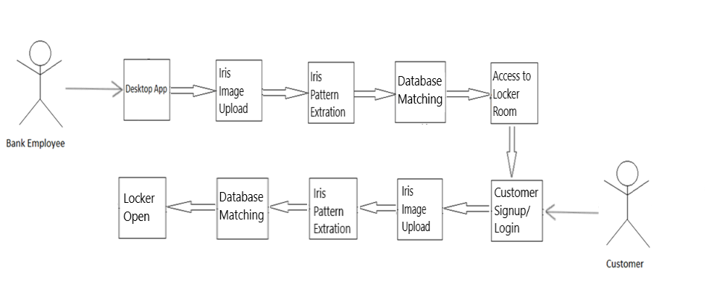

**Figure 4.1:1 System Architecture**

* 1. **Process Flow/ Representation**

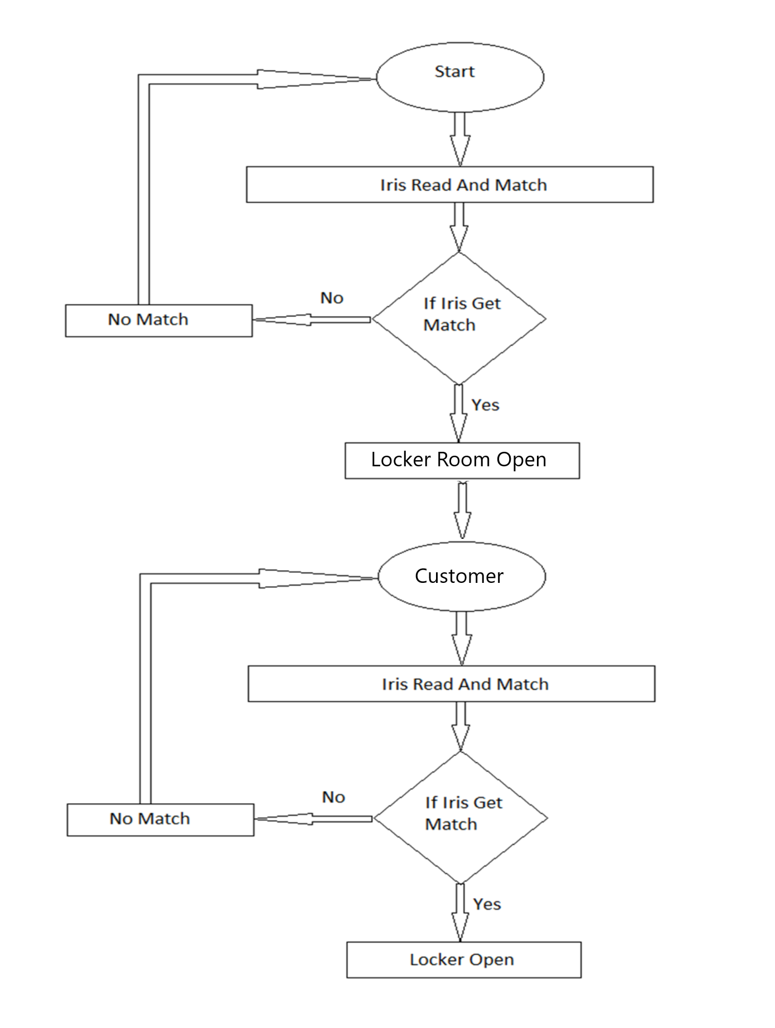

**Figure 4.2:1 Activity Diagram**

* 1. **Data Representation**

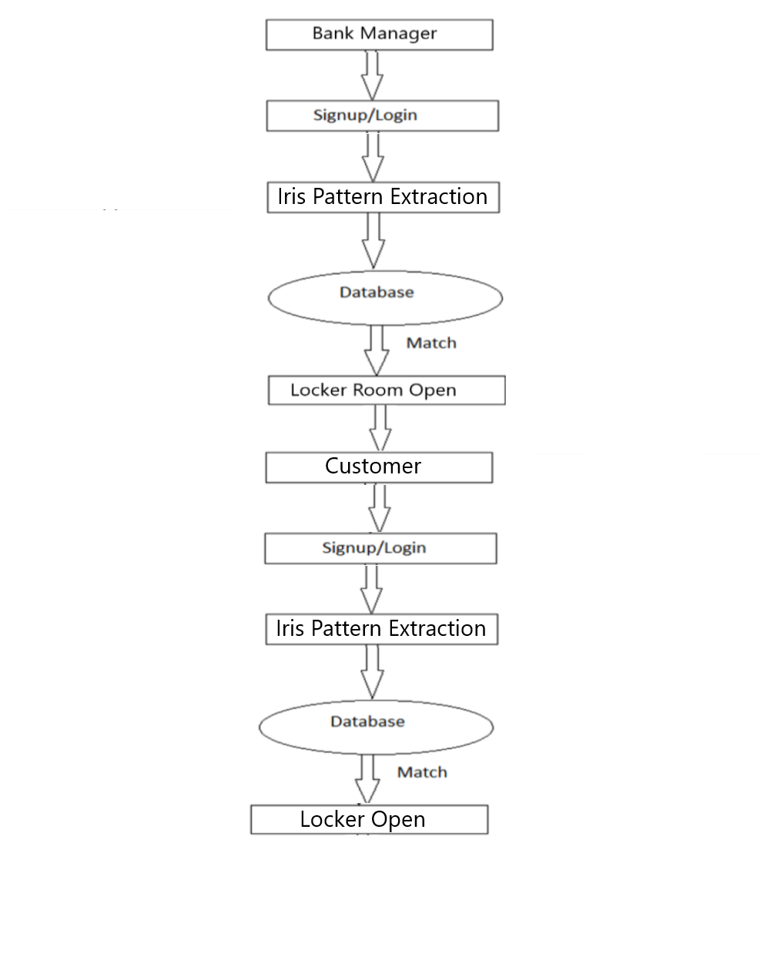

**Figure 4.3:1 Level 0 Diagram**

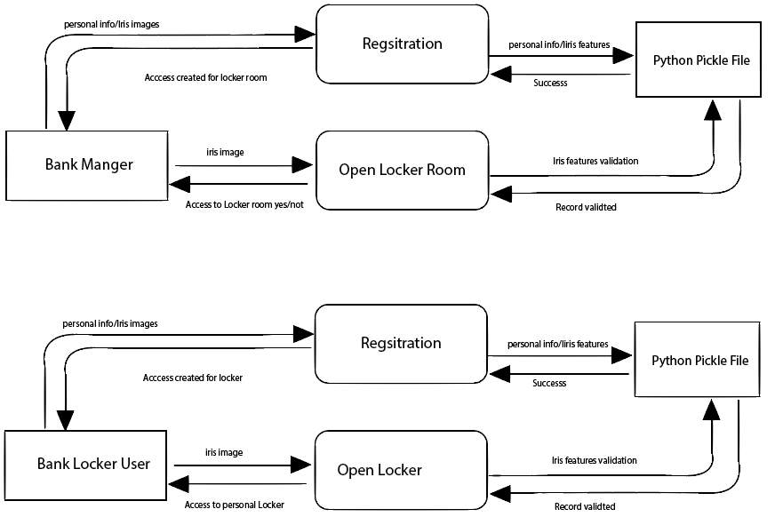

**Figure 4.3:2 Level 1 Diagram**

* 1. **Design Models**

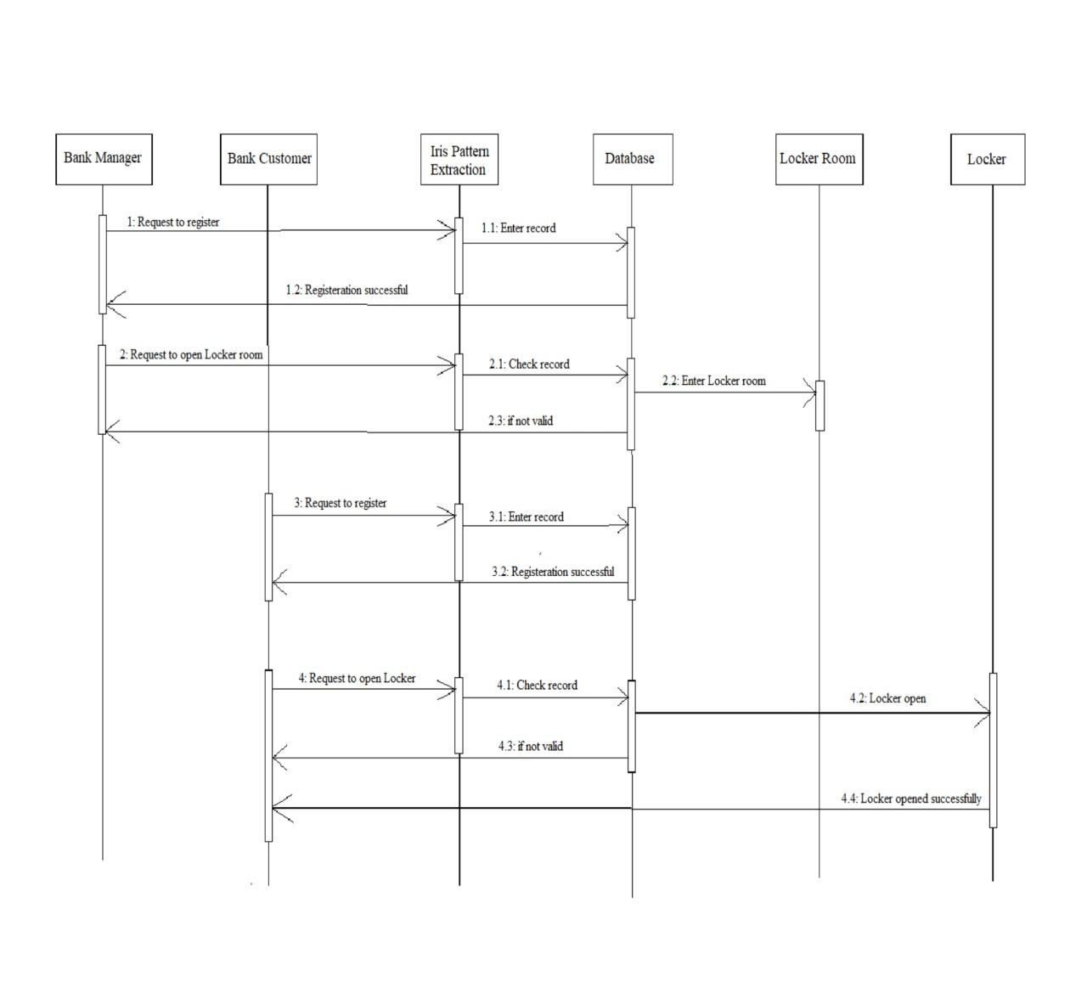**Figure 4.4:1 Sequence Diagram**

**Chapter No. 05**

**Implementation**

# **Implementation**

## **5.1. Project Implementation**

Tkinter is used for interface design. As Tkinter is used for binding of python to the Tk GUI toolkit. Tkinter is used as standard Python interface to the Tk GUI toolkit. It is also a de facto framework of Python GUI. Main qualities of Tkinter are that it is free and open source.

It was developed by Fredrik Lundh. Tkinter was released under Python license. Tkinter is a cross-platform, because of which the same code work on windows, Linux and macOS. Tkinter is easier to use as compared to other frameworks.

The main and positive point of Tkinter is that it is free in versions of 32 and 64 under Python license.

## **5.2. Tools And Techniques**

We used following tools and techniques for implementation of our project:

Tkinter, Python and Pycharm.

**5.2.1 STAGES OF IRIS RECOGNITION**

It has the below mentioned step for iris recognition

* **Image**: In the first step picture is taken under proper constraints. All the constraint must be taken into consideration because iris recognition high quality image with proper device. It is very important step because iris localization purely depend on that.
* **Image preprocessing**: After that image captured process pre processing is performed. It includes conversion of image to gray scale. We convert image to gray scale as we need to detect the edge of iris. Gray scale provide image in only two color with intensity from 0 to 255.

**Y = 0.2125 R + 0.7154 G + 0.0721 B [4]**

After that Gaussian Blur is applied to flatten the image in this way noise is removed from image.

**[5]**

* **Image localization**: In this step previous processed image is use to find the iris from image we applied the threshold function. Using threshold it use fixed-level threshold to a one-channel of array. It is used to get binary image bit level from image which is converted to grayscale earlier to remove noise from it, it filter out pixels which are too small or too large than threshold value **[6]**.

\texttt{dst} (x,y) =  \fork{\texttt{maxval}}{if $\texttt{src}(x,y) > \texttt{thresh}$}{0}{otherwise}

We applied canny edge detector to that threshold which return the edges. Than using the Hough circle we detect the iris by using cv2.Houghcircle. It is method use to detect circle. Hence it return the circular iris region to us by drawing circle we applied that mask to our original and detect the iris region by cropping out the region which not of our interest.

**cv2.HoughCircles(image, method, dp, minDist[, circles[, param1[, param2[, minRadius[, maxRadius]]]]]) → circles .[7]**

* **Feature extraction**: From our region of interest the is localize we extract texture feature using Gabor kernel. Features are the pattern of iris used for verification purpose.

**cv2.getGaborKernel(ksize, sigma, theta, lambda, gamma, ktype)**

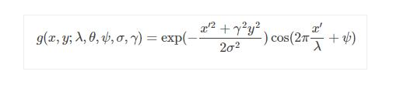**[8]**

## **5.3. Main-Interface**

User interface help the user to visit the application and perform their required actions. The importance of an interactive and easy interface cannot be denied because the interface is the medium between user and the machine to interact with each other. User Interface which is difficulty free and have attraction appeals the user a lot. A user demand’s that the interface should be problem free. Smart Bank Locker based on Iris Recognition is an application which keep the bank employ and the bank customer engaged. Now, we move toward our user interface of our application.

## **5.4. Main Menu**

In this application we provide all the options at the home page of our application. A bank employee can see all the options like signup and login for proceeding in the lockers. We also have same options like signup and login for bank customer. If bank employee and the bank customer have an account then they can login and enter in the lockers otherwise they will have to signup for availing the permission.

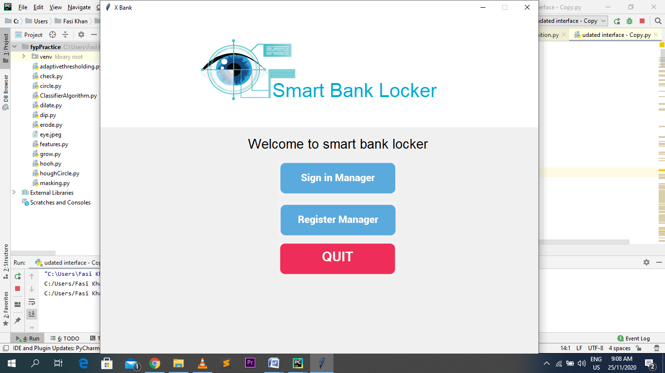

**Figure 5.4:1 Interface**

## **5.5. Bank Employee Functionalities**

The bank employee can perform following functionalities on our application in order to avail our services:

### **5.5.1** **Register Manager**

Bank manager require to register him/her self. The registration of bank manager deal with main bank locker room. It visualize the hold of main bank locker room to bank manager. The employee will have to provide the required information about him/her like iris image to register him/herself on our application.

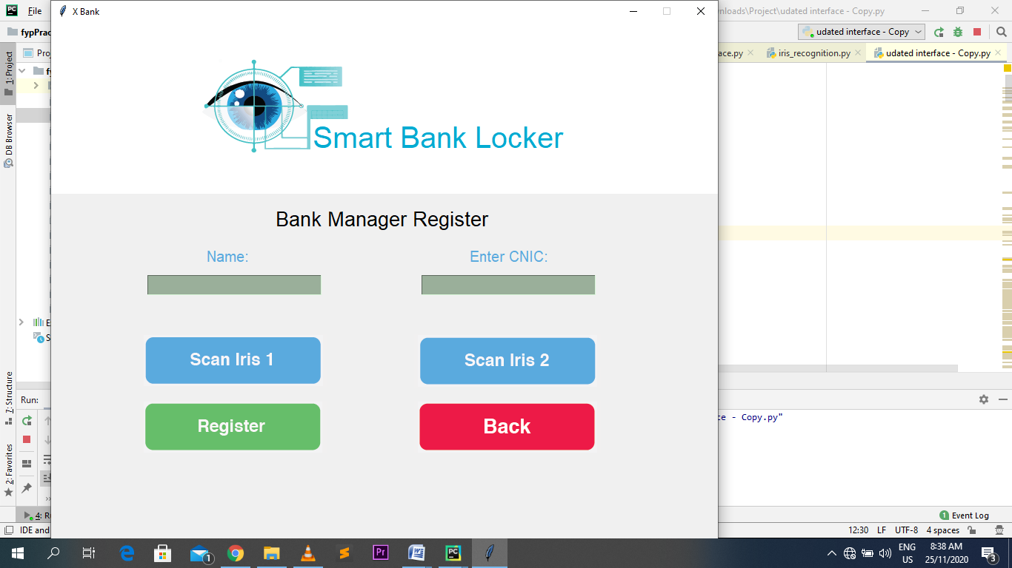

**Figure 5.5:1 Manager Registration**

### **5.5.2 Access Locker Room**

In order to access the locker it is mandatory first to open main locker room. Main locker room is associated with the bank manger iris. In to access that main room bank manger iris pattern must be matched otherwise access will not be given

In login activity a bank employee will have to match his/her iris patterns then click on open locker room button for entering into visual bank locker room

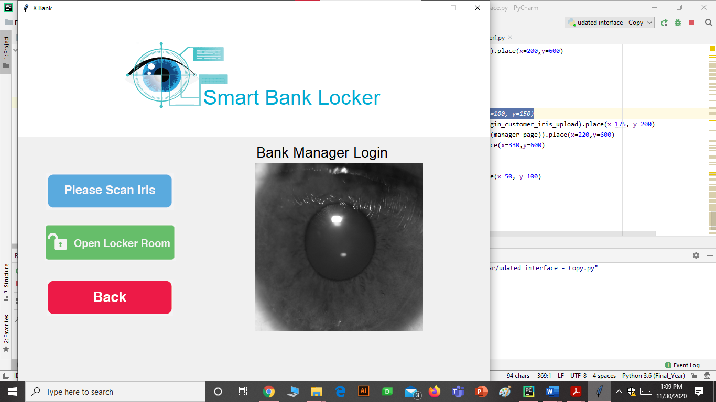

**Figure 5.5:2 Locker Room Opening**

## **5.6. Bank Customer Functionalities**

The bank customer can perform following functionalities on our application in order to avail the services:

### **5.6.1 Locker User Registration**

Bank customer will have to register him/her before availing our services (Entering the lockers). The customer will have to provide the required information about him/her like iris image to register him/herself on our application.

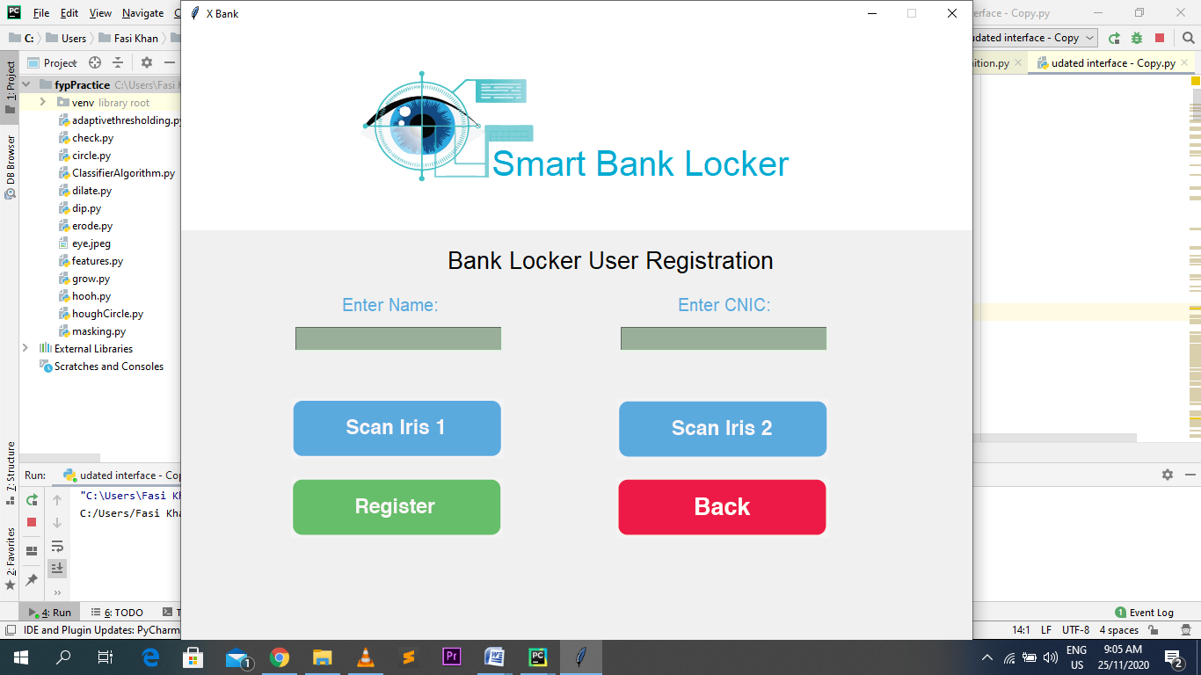

**Figure 5.6:1 Bank Locker User Registration**

### **5.6.2 Locker Opening**

In locker opening activity bank locker user pride his/her iris image. On the basis of features extracted from that image access to locker is allowed is allowed.

In this activity a bank customer will have to match his/her iris patterns then click on open locker button for login to his account.

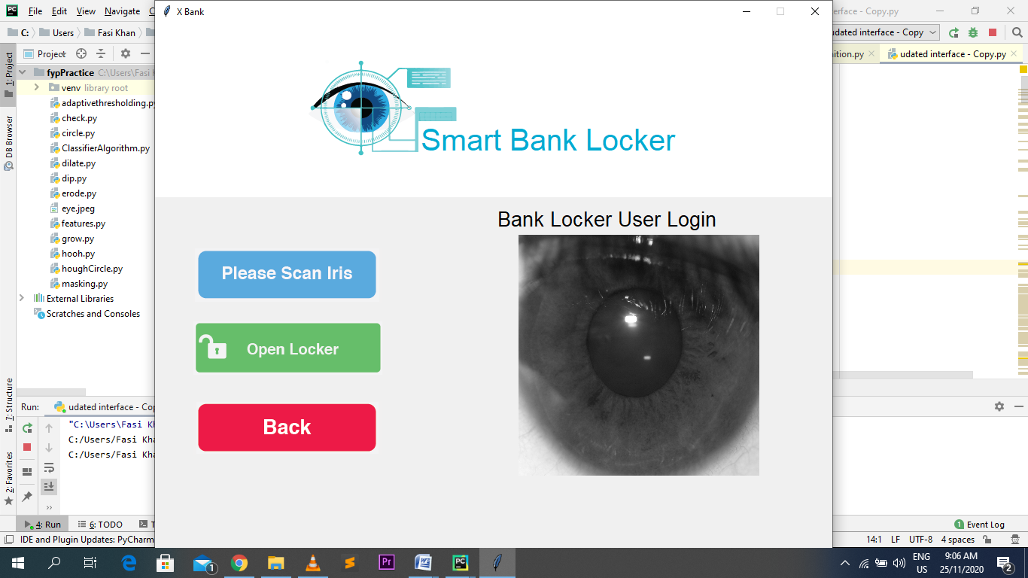

**Figure 5.6:2 Locker Opening**

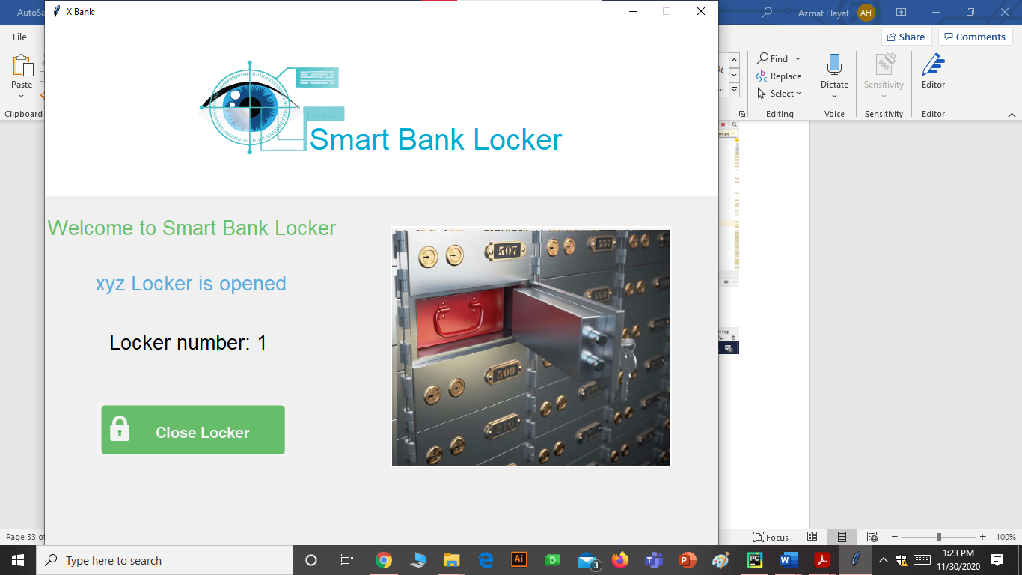

**Figure 5.6:3 Opened Locker**

**Chapter No. 06**

**Testing**

# **6. Testing**

## **6.1 Project Testing**

For finding the errors in a project/program we have to run it for several times. Testing is the step for improving the quality of the software. We have used two types of testing in our project, first is Functional testing and the other is System testing.

## **6.2 Functional Testing**

According to the requirements, functions can be tested through functional testing. In this, we can give the input to examine the system. By using Functional testing, we examine the functionality of our system whether the system fulfil the requirements or not.

### **6.2.1 Registration System:**

|  |  |  |  |  |
| --- | --- | --- | --- | --- |
| **Manager Registration:** | | | | |
| **No** | **Test condition** | **Expected result** | **Actual output** | **Result**  **(Pass, Fail)** |
| Test 1 | Enter name, CNIC and select an iris image for bank manager registration. | Bank manager can be register and data save in database. | Result as expected. | Pass |
| Test 2 | Click the submit button after filling personal information and iris image. | Registration can be done. | Result as expectations. | Pass |
| Test3 | After registration, bank manager can login the account. | Login page can be display. | Result as expected. | Pass |

**Table 2 Test case for Registration**

### **6.2.2 Locker Room Access**

|  |  |  |  |  |
| --- | --- | --- | --- | --- |
| **Manager Access:** | | | | |
| **No** | **Test Condition** | **Expected result** | **Actual output** | **Result**  **(Pass, Fail)** |
| Test 1 | Enter the iris image of bank manager and click on login button. | Successfully login in the system. | Same as expected. | Pass |
| Test 2 | If the iris image can’t match then user cannot login because the manager with this iris image doesn’t exist in database. | Cannot login in the system. | Same as expected. | Pass |

**Table 3 Test case for Manager Room Opening**

### **6.2.3 Bank Locker User**

**Table 6.3 Test case for Locker User**

|  |  |  |  |  |
| --- | --- | --- | --- | --- |
| **No** | **Test condition** | **Expected result** | **Actual output** | **Result**  **(Pass, Fail)** |
| Test 1 | Bank manager can make account for customer after that customer can access locker. | Account can be created and then login. | Same as expected. | Pass |
| Test 2 | When customer make an account, customer should enter cnic and the iris images. | Account can be saved in the database. | Same as expectation. | Pass |

**Table 4 Test case for Locker User**

## **6.3. System Testing**

The whole system is examined thoroughly by system testing. System testing is conducted to evaluate the system compliance according to the requirements. System testing is also used to check the defects in the whole system.

**Chapter No. 07**

**Conclusion and Future Work**

# **7. Conclusions**

## **7.1. Conclusions**

Conclusion of Smart Bank Locker based on Iris Recognition is that the system is very reliable and user friendly for both bank manager and the bank customer. As the bank need security for bank lockers so that there will be no illegal access, this is the system which helps the bankers to secure their lockers so that the unconcerned person cannot access the locker. This system gives both bank manager and bank customer the independence of keys of the lockers.

## **7.2. Future Work**

*In future, there will be a combination of iris and fingerprints for security of bank lockers.

* In future, there will be an increase in database to facilitate large numbers of bank customers.

## **7.3. References**

[1] P Tripathi, “A Comparative Study of Biometric Technologies with Reference to Human Interface,” International Journal of Computer Applications (IJCA), vol. 14, no.5, 2011.

[2]Padma, Manivannan, “Comparative and Analysis of Biometric Systems” International Journal on Computer Science and Engineering (IJCSE,) vol. 3, no. 5, pp2156-2162, 2011.

[3] Tilo Burghardt, “A brief review of biometric identification,” University of Bristol, UK

[4] <http://poynton.ca/PDFs/ColorFAQ.pdf>

[5] <https://www.sciencedirect.com/topics/engineering/gaussian-blur>

[6] <https://docs.opencv.org/2.4/modules/imgproc/doc/miscellaneous_transformations.html#threshold>

[7] https://docs.opencv.org/2.4/modules/imgproc/doc/feature_detection.html?highlight=houghcircles

**[8]** ]https://www.programmersought.com/article/58896149383/